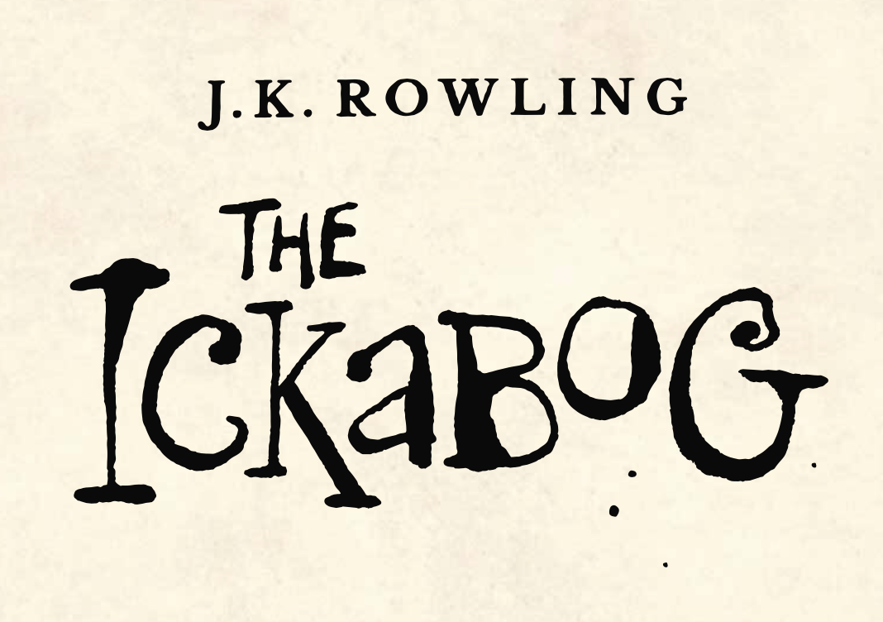

In Chapter Five we discover how Daisy Dovetail is getting on in her new home. She is getting sadder every day that passes since her mother died. For a while she is able to wear all the dresses her mother once made for her.

Draw a different dress design on each strip of paper. Then cut out the strips and make a Flip-O-Rama. On each strip of paper try to make Daisy Dovetail slightly larger, so her dresses appear to become smaller and smaller and smaller.

